
QSTEMora club
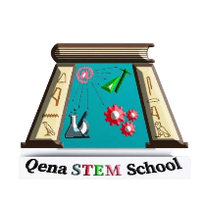
Dear School Principal,
We are pleased to introduce our student team and its initiative to support and guide students throughout their school journey.
The team was originally founded within the Class of 2026 by Mohannad Naeem, Yassin Ahmed, Youssef Saeed, and Youssef Mohamed. Following their graduation, the initiative was continued by the Class of 2028, with Mahmoud Ramadan and Mai Mahmoud as its founders.
Our primary goal is to make the transition into the school system easier for Grade 10 students by providing them with the knowledge, resources, and guidance they need to continue their road at STEM.
Our activities include:
- Preparing study materials and organized resources.
- Collecting and sharing practice questions and useful references.
- Conducting educational sessions for students.
- Sharing practical experience in STEM, competitions, projects, and technical skills.
- Guiding students and helping them understand opportunities they may not yet be familiar with.
Ultimately, our goal is to establish a student-led support system where knowledge and experience are continuously passed from one generation to the next.
Sincerely,
QSC Team
Founders: Mahmoud Ramadan & Mai Mahmoud

Deputy Signature
leaders Signatures
Principal Signature

